The Coalition for Physician Enhancement (CPE)
Fall 2013 Meeting, October 24-25
Hilton, Sundance Square
Fort Worth, TX

Changing Scope of Practice: Implications for Physician Assessment, Education, and Patient Safety

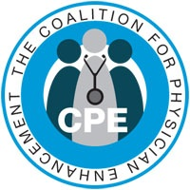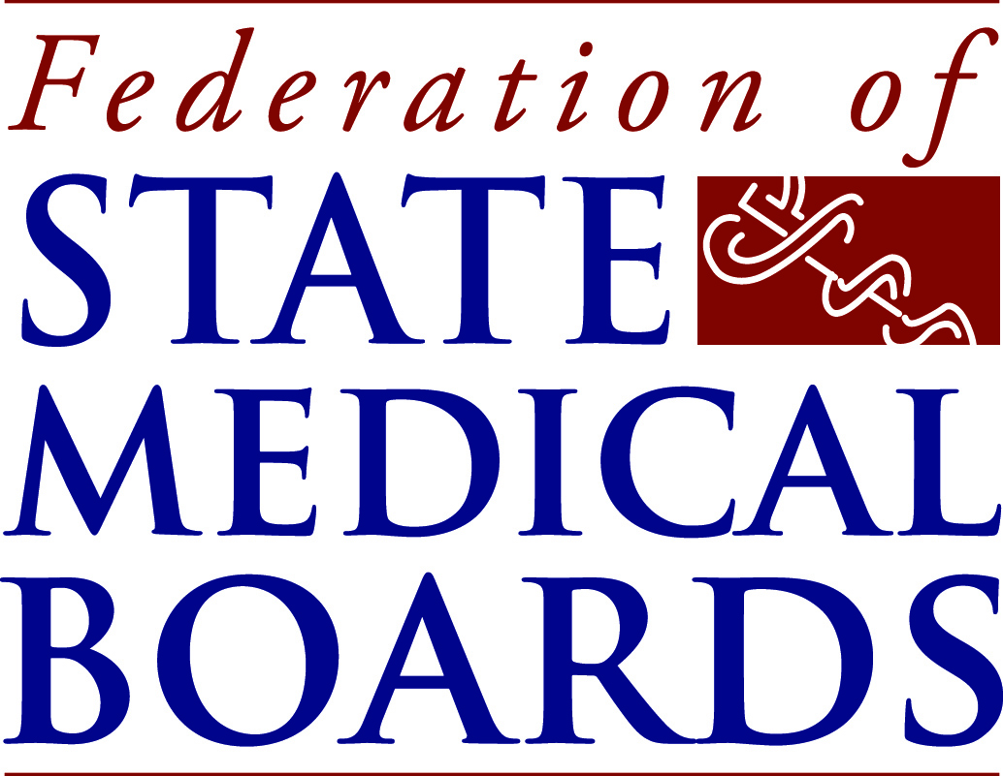
COALTION FOR PHYSICIAN ENHANCEMENT (CPE) FALL 2013 CONFERENCE
Changing Scope of Practice: Implications for Physician Assessment, Education, and Patient Safety
Hilton, Sundance Square, Fort Worth, Texas
October 24-25, 2013

Overview
This program was developed by the Coalition for Physician Enhancement (CPE) program committee and is jointly sponsored by the KSTAR Physician Assessment Program, Texas A&M College of Medicine, and the Federation of State Medical Boards (FSMB). This meeting topic was chosen to explore and further develop our approach and use of physician scope of practice information when we assess physician skills and provide continuing professional development. We will also be addressing patient safety and regulatory concerns when scope of practice changes. For the purpose of this meeting, scope of practice is defined as the profile of the types of patients, medical problems, and procedures that comprise a physician’s practice. Although discussions on scope of practice can at times become political and refer to practice boundaries or “turf battles”, this program is not intended to address that aspect.
Program Objectives
- Understand the definition of scope of practice as it applies to this program, and its importance to physician assessment, education, and patient safety
- Learn how medical boards and other regulatory entities in North America gather data related to scope of practice and how they manage changes of scope
- Hear and discuss case presentations that involve scope of practice and/or changes of scope
- Identify specific types of assessments and educational programs where considering scope of practice may/may not be beneficial
- Understand the limitations to which assessment can be tailored
- Identify the types of changes in scope of practice that can and do occur, and distinguish which types and degrees are more problematic
- Understand the key pieces of information needed from physicians to identify changes in scope of practice
- Understand the competency evaluation/educational needs with various types of scope change
- Learn about potential sources of data that can be used to capture scope of practice information
- Identify potential partners for the development of a common care data set for scope of practice
- Understand your own agency’s data strengths and gaps with regard to capturing scope of practice for programming needs
CHANGING SCOPE OF PRACTICE: IMPLICATIONS FOR PHYSICIAN ASSESSMENT, EDUCATION, AND REMEDIAL EDUCATION
AGENDA

Day 1 Thursday, October 24th

7:15-8:00 AM Registration/Continental Breakfast
8:00 -8:15 AM Welcome and Opening Remarks
Frances Cain – Vice-President, Assessment Programs, Federation of State Medical Boards (FSMB)
Robert Steele, MD- Medical Director Texas A&M KSTAR Physician Assessment Program; President-Elect CPE

8:15- 9:00 AM Keynote Address: Changing Scope of Practice: Approaches to Physician Assessment and Education
Richard E. Hawkins, MD, FACP - Vice President, Medical Education Programs, American Medical Association
9:00- 9:45 AM Practice Drift and Its Effect on Quality of Care: The Policies and Practices of the North Carolina Medical Board
William A. Walker, MD- President, North Carolina Medical Board
Thomas Mansfield, JD – Legal Director and Legislative Liaison, North Carolina Medical Board

9:45 –9:55 AM Case Studies in Scope of Practice, Presentation #1
9:55 – 10:15 AM Break
10:15 – 10:55 AM Managing Changes of Physician Scope of Practice in Ontario, Canada: A Review from the College of Physicians and Surgeons, Ontario (CPSO)
Risa Bordman, MD, CCFP – Medical Advisor, College of Physicians and Surgeons of Ontario
10:55 – 11:05 AM Case Studies in Scope of Practice, Presentation #2

11:05 – 11:45 AM Slip Slidin’ Away: Practice Change and Implications for Physician Performance
Elizabeth S. Grace, MD – Medical Director, Center for Personalized Education of Physicians (CPEP), Denver, CO
11:45 AM – 12:15 PM Panel Discussion of Morning Presentations
Moderator: Rob Steele, MD
12:15 – 1:30 PM Lunch – Hilton, Sundance Square
1:30 – 1:40 PM Case Studies in Scope of Practice, Presentation #3
1:40 – 1:50 PM Introduction to Workshops on Scope of Practice
Elizabeth Wenghofer, PhD - Associate Professor and Director, School of Rural and Northern Health, Laurentian University, Ontario
Sophia Kam, MA – PhD Student at the School of Rural Northern Health, Laurentian University, Ontario

There will be two workshops for the afternoon session, allowing all participants to attend in both. You will be assigned to a group when you register for the course.

Workshop #1: To Tailor or Not To Tailor?
This workshop will discuss the pros and cons, challenges, and barriers of tailoring performance assessments to a physician’s scope of practice. Participants will discuss:
- Whether or not their current assessment processes are tailored to a physician’s scope of practice
- How they currently go about determining the physician’s scope of practice
- The degrees to which assessments are currently tailored and customized
- To what degree should tailoring occur, or should there be a base set of competencies that all physicians, regardless of scope of practice, should be able to meet

Workshop #2: Change? What Change?
This workshop examines the types of scope of practice changes that physicians may experience throughout their careers. Working in small groups, participants will contemplate:
- Whether or not scope of practice should be monitored from a regulatory and/or continuing professional development perspective
- The types and degrees of changes that should be considered as a change in scope of practice
- Whether or not degrees of change have different requirements regarding competency and performance assessment
- How (and if) changes in scope of practice are currently managed

1:50 – 3:00 PM Afternoon workshops – Session One
3: 00 – 3:20 PM Break – then rotate to the other workshop
3:20 – 4:30 PM Afternoon Workshops – Session Two
4:30 – 4:45 PM Recap and Report Out of Afternoon Sessions
Vote for Best Scope of Practice Case Presentation, Adjourn
630 PM Optional dinner (requiring separate fee) at Reata – 310 Houston Street, Fort Worth. American/southwestern cuisine, a few blocks away from the Hilton; website www.reata.net.

Day 2, October 25 AGENDA

7:15 – 8:00 AM Continental Breakfast
8:00 – 8:15 AM Summary of Day #1/Day #2 Agenda
Robert Steele, MD
Day #2 Workshop Description and Instructions
Elizabeth Wenghofer, PhD

8:15 – 10:00 AM Workshop #3: How Do We Scope Scope?
This workshop will review key concepts and messages from workshops #1 and #2 regarding the types of information that are needed to tailor assessments and understand changes in scope of practice. Participants will work in small groups to discuss:
- The minimum data that should be collected to capture scope of practice
- Where the data may already exist and how it could be shared
- By whom and how this data should be collected if practice profile data does not already exist
- How stakeholders (including conference participants) could work together to collect such data

10:00 – 10:20 AM Break
10:20 – 11:00 AM Polling and Final Thoughts on Integrating Scope of Practice into Physician Assessment, Remedial Education, and Patient Safety
11:00 – Noon CPE Business Meeting – CPE Members Invited.
To all: Safe Travels Home!

ADDITIONAL ACTIVITIES AND INFORMATION

Disclaimer
It is important to let all participants know that there may be one or more publications that summarize the key messages and themes that emerge from the workshops and conference discussions. It is hoped that the learning and knowledge gained from fruitful interactions will be shared broadly in a conference summary publication and/or used to guide future research projects. At no time will any direct quotations be utilized nor attributed to identified individuals to insure anonymity of participants unless written consent/permission is received from specific individuals

Tour of the JPS Mini-Residency!
The John Peter Smith (JPS) Mini-Residency Program will be hosting an informal tour and explanation of the assessment process and educational process for re-entry and remedial education of physicians. You will also be able to talk to physicians who are going through the program. If you would like to attend this event, there will be a section on the online registration form where you can indicate your interest. You will be sent an invitation by the mini- residency program to your e-mail address with additional information. The date and time will be Wednesday, October 23rd, 3 PM Central Daylight time, so be sure to take that into consideration when you plan your travels if you would like to attend! You will likely have to provide your own transportation, but we will see if there are other options available – so keep an eye on our website: www.cpememberlodge.org

Certificates of Attendance
A certificate of attendance will be provided to all program attendees at the end of the course when the final course evaluations are collected. The certificate will contain the conference title, dates, location, and the maximum number of hours that can be claimed if all components of the program are attended. If you use the certificate to verify you attendance to this group activity, it is suggested that you claim only the hours you actually attended the course.

Meet and Greet on Wednesday, October 23 - Evening
The program committee and sponsors may try to arrange for an informal meet-and-greet gathering, likely at a local downtown restaurant or club, for those who want to socialize and network. Please keep an eye on our website for further developments! www.cpememberlodge.org

Case Presentations in Scope of Practice – Consider Presenting!
There are three places in the agenda for brief presentations and discussion afterward of case studies in scope of practice. Each presentation has 10 minutes for both presentation, subsequent questions, and discussion from the audience. Please consider sharing a case (or cases) where scope of practice somehow informed or affected and assessment, educational program, or patient safety. The presentations are not highly structured, but should include how a “problem” or some type of discovery came to light, and what ended up happening because of it. If you have any questions, please contact Rob Steele, MD at: steele@tamhsc.edu. The audience will vote on the best presentation, and there will be prizes (also…there will be no air horns this time.) We will send out a reminder requesting presenters for this activity about 6 weeks prior to the meeting.

Hotels on or Near Sundance Square
Hilton Forth Worth, Downtown (conference hotel) – Sundance Square, 815 Main Street, Fort Worth, TX, 176012, www.Hilton.com, (800) HILTONS, or (817) 870-2100.
Conference rate: $139/night. There is a block of rooms reserved for our conference at that rate. Reserve early to make sure you get the best rate. If the rooms run out, the conference rate cannot be guaranteed.
Reservations online can be made through the following link:
http://www.hilton.com/en/hi/groups/personalized/F/FTWFWHF-FED-20131023/index.jhtml?WT.mc_id=POG
Alternatively, if calling, be sure to mention that you are attending the CPE meeting when you reserve, and use the code “FED” in addition to mentioning the CPE meeting.
A few other options are listed below in case you need or prefer other lodging. There are other options available nearby—just do a web search with “hotels Sundance Square, Fort Worth”.
Courtyard by Marriott, Fort Worth – Downtown/Blackstone, 601 Main Street, Fort, Worth, TX, 76102, www.marriott.com, (817) 885-8700.
Etta’s Place (boutique hotel), Fort Worth – Downtown, 200 W. 3rd Street, Fort Worth, TX, 76102, www.ettas-place.com, (866) 355-5760 or (817) 255-5760.
Omni Fort Worth – Downtown, 1300 Houston Street, Fort Worth, TX, 76102, www.ominhotels.com, (817) 535-6664.

