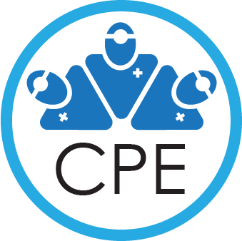

2023 Annual CPE Conference, September 26-27, 2023
Hyatt Regency Salt Lake City

Keynote Presentation: From Languishing to Thriving –
What’s really working for physicians who need help?
Presented by Ryan Bayley, MD

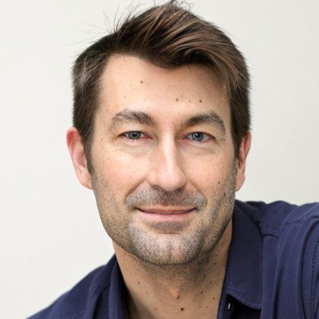
Dr. Bayley is an executive coach and physician advocate who has worked with thousands of clinicians to optimize their careers and happiness. To that end, he is the founder of Bayley Coaching Solutions, a physician-focused executive coaching and consulting firm. His group works with multiple states’ medical boards and physician health programs, as well as individual healthcare organizations. In addition to his coaching and consulting work, he is a nationally recognized speaker and author, as well as a consultant to large healthcare organizations.

Dr. Bayley completed his undergraduate at Harvard, and subsequently attended Vanderbilt Medical School. He completed his residency in emergency medicine at Columbia and Cornell Universities (New York-Presbyterian) and his EMS fellowship with the Fire Department of New York. In addition to his executive coaching and consulting, he still practices emergency medicine and serves as an emergency medical services director for 911 systems. He also currently holds an associate adjunct position at Duke University Medical Center, where he leads courses on physician well-being and career design.

