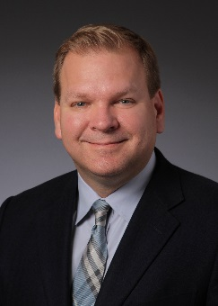
Chris Bundy, MD, MPH

Dr. Bundy is the Executive Medical Director of the Washington Physicians Health Program (WPHP), Immediate Past President of the Federation of State Physician Health Programs and Clinical Associate Professor of Psychiatry, University of Washington School of Medicine, and Washington State University Elson S. Floyd College of Medicine. Prior to joining WPHP, he served as Mental Health Service Chief and Chief of Psychiatry at the VA Puget Sound Healthcare System. He is board certified in general and geriatric psychiatry and addiction medicine. Dr. Bundy draws on his experience as a health-care leader, medical educator, and recovering physician to support education and advocacy efforts related to physician health and well-being.

